Flexibility technologies in clean energy systems
Dawei Qiu^{1,2}, Goran Strbac¹, Cuo Zhang³, Zhao Yang Dong & Iain Staffell⁴
¹Department of Electrical and Electronic Engineering, Imperial College London, London, UK. ²Department of Engineering, University of Exeter, Exeter, UK, ³School of Electrical and Computer Engineering, The University of Sydney, Sydney, Australia. ⁴Centre for Environmental Policy, Imperial College London, London, UK.
Abstract [203]
As global energy systems transition toward net-zero emissions, maintaining a real-time balance between supply and demand – known as energy system flexibility – has become a critical challenge. This challenge arises from the increasing penetration of variable renewable energy, the electrification of heat and transport, and the decarbonization of gas infrastructure, all of which introduce unprecedented variability and operational uncertainty. In this Review, we examine the technologies and associated operational strategies that provide flexibility across clean and sustainable energy systems, enabling reliable, efficient, and low-carbon energy delivery. We categorize flexibility into electricity system flexibility and gas and hydrogen system flexibility, encompassing both supply-side and demand-side mechanisms. Technologies such as clean dispatchable generation, large-scale storage, grid interconnectors contribute to electricity system flexibility, while linepack, hydrogen electrolysis, and gas-fired generation offer critical balancing services in gas and hydrogen networks. Simultaneously, demand-side response – enabled by digitalization and decentralization – is emerging as a scalable, distributed source of flexibility across the residential, commercial, industrial, and transport sectors. We also discuss key technical and economic barriers to the widespread deployment of flexibility technologies and explore how energy market structures and regulatory frameworks must evolve to unlock investment in flexibility at scale. Ultimately, achieving a decarbonized energy future will require the coordinated integration of diverse flexibility technologies across interconnected multiple energy vectors.
Introduction [644]
Global efforts to decarbonize energy systems have been accelerating in response to an urgent need to mitigate climate change. Central to this transformation is the widespread electrification of end-use sectors, particularly heat and transport, alongside the rapid deployment of low-carbon energy sources. These include variable renewable energy resources (vRES) such as wind and solar, and emerging green fuels like hydrogen. By the end of 2024, global installed vRES capacity reached ~5.4 TW, while global electrolyser capacity for green hydrogen surpassed 1.75 GW in 2023, with projections indicating a need for ~200 GW by 2030 to meet net-zero targets.
While these developments are critical to achieving the net-zero targets, they have also been fundamentally reshaping how energy is generated, delivered, and consumed. A defining characteristic of evolving energy systems is the sharp increase in variability and uncertainty, which poses significant challenges for maintaining a real-time supply-demand balance and system reliability. For instance, in the UK, the growing reliance on wind power has introduced substantial variability. In December 2024, wind energy supplied over 50% of the country’s electricity on about ten days; however, by 12 December, output suddenly dropped to just 6% during an extended period of low wind speeds – a phenomenon so-called “wind droughts.” In Australia, by June 2025, a combined photovoltaic (PV) capacity of over 41.8 GW which is higher than the peak loads has been achieved. Usually such high PV power generation leads to energy surplus during midday with negative electricity prices in the wholesale market, but dropping PV power generation and increasing demand then induces heavy energy shortage in late afternoon and thus price spikes of over thousands of dollars per MWh. Similarly, in 2024, the rapid uptake of electric vehicles (EVs) and heat pumps added an estimated 1.5 TWh to the UK’s electricity demand, while the installation of 4 million additional heat pumps increased peak demand by 18%. This surge in electrification also amplifies uncertainty in demand patterns, as charging and heating behaviors are increasingly shaped by diverse user preferences and dynamic daily routines.
Together, these factors reduce the predictability and controllability of energy systems, exposing the limitations of traditional approaches that historically relied on the flexibility of gas- or coal-fired plants, and large-scale fuel or hydro storage to absorb demand fluctuations and maintain system stability. In contrast, clean energy systems are shifting toward greater reliance on non-dispatchable renewables while progressively phasing out high-emission, dispatchable sources such as coal and oil. These trends are diminishing the inherent flexibility of conventional energy systems, amplifying the need for new, responsive forms of flexibility to ensure secure, efficient, and low-carbon operation.
Flexibility refers to the ability of energy systems to quickly and effectively respond to short- and long-term variations in supply and/or demand while maintaining overall system stability, safety, and efficiency. This spans multiple timescales – from sub-second grid frequency response to seasonal energy shifting – and operates across multiple energy vectors, including electricity, gas and heating. Flexibility can be delivered through a broad portfolio of technological and systemic solutions. These include supply-side technologies such as clean dispatchable generation, large-scale electricity storage, and cross-border grid interconnectors; demand-side technologies such as industrial load shifting, smart home energy management, and vehicle-to-grid (V2G) integration; and multi-vector technologies such as power-to-gas and electrified heat integration. Increasingly, digital innovations – such as real-time sensing, AI-based forecasting, and automated control platforms – are enabling responsive, decentralized flexibility, particularly from distributed energy resources (DERs). Yet the provision of flexibility is not purely a technical matter, market design and regulatory frameworks must also evolve to appropriately recognize, evaluate, and incentivize flexibility services, particularly where they can compete with or defer conventional network infrastructure investments.
In this Review, we begin by identifying the flexibility needs of clean energy systems, followed by a comprehensive discussion of the technologies and associated operation strategies that enable their effective delivery. Our analysis is organized around three core domains: supply-side resources, demand-side enablers, and multi-vector integration. Within this framework, we assess the functionality and technical features, system-level contributions, and value propositions of each flexibility technology. We also evaluate their current global deployment status and highlight key technical and economic barriers to broader adoption. Building on this, we explore how market structures and regulatory frameworks must evolve to effectively incentivize and scale up flexibility investment in a cost-effective and equitable manner. Finally, we emphasize the systemic importance of flexibility and advocate for a whole-system approach towards net-zero transitions.
Flexibility needs [1239]
Fig. 1 | Flexibility needs in clean energy systems. Clean energy systems face increasingly flexibility needs due to the growing integration of variable renewable energy sources (vRES) such as wind and solar, the electrification of heat and transport via heat pumps and electric vehicle charging, and the decarbonization of gas infrastructure through green hydrogen. Panels (a-f) illustrate six key system challenges and the corresponding flexibility needs across the world. a, Power balancing, including long-duration balancing to manage multi-day renewable shortfalls (e.g., the UK Dunkelflaute event in December 2021) and short-term balancing to address day-ahead half-hourly forecast errors in wind generation. b, Load ramping to accommodate rapid changes in net load during late morning and early evening due to large-scale solar integration – illustrated by California Independent System Operator (CAISO) "duck curves" over three years. c, Congestion management and peak shaving to relieve grid bottlenecks and manage growing demand peaks associated with end-use electrification (e.g., the Netherlands grid congestion). d, Frequency response to stabilize system frequency following disturbances, with an emphasis on improving rate of change of frequency (RoCoF) and nadir in low-inertia, vRES-dominated systems. e, Voltage regulation to address localized overvoltage and undervoltage conditions, ensuring voltage quality and reliability across distribution networks. f, Resilience enhancement to support staged load restoration following the Spain-Portugal blackout. Panel a adapted from ref. x, NESO. Panel b adapted from ref. x, IEA. Panel c adapted from ref. x, xxx. Panel d adapted from ref. x, xxx. Panel e adapted from ref. x, xxx. Panel f adapted from ref. x, REE.
Energy system flexibility was traditionally delivered by adjusting supply to follow demand, with dispatchable generators able to ramp output up or down easily and quickly to maintain system balance and respond to contingencies. This approach relied on the controllability of fossil fuel power plants, characterized by technical parameters such as ramp rates, start-up/shut-down times, and minimum up/down durations. However, the ongoing energy transition is fundamentally reshaping both supply and demand dynamics, substantially increasing the need for flexibility. On the supply side, the rapid integration of vRES introduces greater short-term variability and forecast uncertainty. Simultaneously, these non-dispatchable sources are displacing conventional generators, reducing access to traditional sources of flexibility. On the demand side, the electrification of transport and heating is introducing new, decentralized, and behavior-driven loads that are more volatile and less predictable. Meanwhile, gas decarbonization and the growing role of hydrogen are deepening interdependencies across energy vectors, further complicating real-time operations. Together, these developments reduce system predictability and controllability, amplifying the need for enhanced flexibility across supply, demand, and multi-energy domains. Fig. 1 illustrates six representative flexibility needs in clean energy systems.
Power balancing maintains continuous real-time balance between electricity supply and demand, which is a fundamental operational requirement in clean energy systems. As generation becomes increasingly weather-dependent, flexibility needs emerge across all timescales. In the short term (seconds to hours), flexibility is required to manage real-time deviations, such as those caused by sudden changes in weather affecting renewable output. Over longer term (days to seasons), flexibility is needed to address structural mismatches between when electricity is generated and when it is needed. A prominent example is the occurrence of prolonged vRES shortages, known as 'Dunkelflaute', which often coincide with high winter demand and place significant stress on generation adequacy. In December 2021, the UK experienced such an event (Fig. 1a), with daily average reliance on fossil fuels reaching 95% from December 16-21 to maintain system balance. This highlights the urgent need for sufficient, dispatchable flexible capacity to reliably meet demand under variable and uncertain supply conditions.
Load ramping captures rapid changes in net electricity demand over short timeframes, primarily driven by fluctuations in vRES. In clean energy systems with high solar penetration, net load profiles often exhibit the classic 'duck curve' – marked by a midday dip caused by peak solar output coinciding with low demand, followed by a steep ramp in the early evening as solar declines and demand rises. This requires highly responsive flexibility over a minutes-to-hours timeframe, particularly as traditional dispatchable ramping capacity is phased out, increasing residual load variability. The evolution of California Independent System Operator (CAISO) duck curve (Fig. 1b) exemplifies this challenge, with ramping needs exceeding 13 GW in just three hours. These trends underscore load ramping as a central flexibility need in renewable-dominated clean energy systems.
Congestion management addresses the need to maintain secure and efficient electricity flows within the physical and thermal limits of grid infrastructure. In clean energy systems, this challenge is exacerbated by the rapid deployment of distributed energy resources (DERs) like rooftop solar, electric vehicles, and heat pumps, as well as the geographic disconnect between renewable generation sites and load centers. These factors increase the risk of local or regional grid bottlenecks, particularly during periods of high renewable output or electrification-driven demand peaks. In early 2025, grid congestion in the Netherlands left around 7,500 generation projects and 10,000 large users waiting to connect (Fig. 1c). Flexibility is needed to dynamically redirect generation, shift demand, or reconfigure grid flows in real time to alleviate such congestions without overloading lines or compromising reliability. This requires timely, location-specific interventions, typically within minutes to hours, making congestion management a critical flexibility need in highly decentralized clean energy systems.
Frequency response refers to the continuous balancing of electricity supply and demand to maintain system frequency – typically at 50 or 60 Hz. Traditionally, frequency stability is inherently supported by the rotational inertia of large synchronous generators, which act as physical buffers against sudden system disturbances. However, as clean energy systems increasingly rely on vRES such as wind and solar, much of this natural inertia is lost. This reduction leads to steeper and deeper frequency deviations – manifested as a lower frequency nadirs and higher Rate of Change of Frequency (RoCoF) – following disturbances (Fig. 1d). For example, Australia’s National Electricity Market (NEM) has experienced sharp frequency drops and rising RoCoF events due to declining inertia, prompting regulatory mandates for fast frequency response services. To secure operation under these dynamics, low-inertia clean energy systems require rapid and precise frequency response, typically within sub-second to second-level timescales.
Voltage regulation is essential for maintaining power quality and grid reliability, requiring voltage levels to remain within acceptable operational limits across the power network. Traditionally, this function is provided by reactive power support from large synchronous generators. However, as clean energy systems transition toward vRES, this conventional source of voltage regulation is diminishing. Concurrently, the proliferation of DERs introduces bi-directional power flows and increased variability in local voltage profiles, creating localized overvoltage or undervoltage conditions (Fig. 1e) that existing grid infrastructure may not be equipped to handle effectively. In Malta, for example, high levels of rooftop solar have caused reverse power flows, leading to voltage rise and grid instability during oversupply periods. Clean energy systems thus require enhanced flexibility to provide dynamic, location-specific voltage regulation with the ability to inject or absorb reactive power to prevent voltage fluctuations dynamically, typically on seconds to minutes timescales.
Resilience enhancement during extreme events is an increasingly critical flexibility need in clean energy systems. As systems shift from centralized, dispatchable generation to decentralized vRES, their capacity to withstand and recover from large-scale outages becomes more complex and less predictable. A recent example occurred on 28 April 2025, when a blackout in Spain disrupted electricity supply for 12 hours and caused a 15 GW load loss (Fig. 1f). Simultaneously, climate change is driving an increase in the frequency and intensity of extreme weather events, placing additional stress on energy system resilience. Historically, black start and restoration services were delivered by large synchronous generators offering high inertia and autonomous operation. With their progressive phase-out, clean energy systems must rely on a new portfolio of flexible resources capable of supporting load restoration under low-inertia or islanded conditions, with emergency and recovery timescales over minutes to days. Ensuring their availability, coordination, and readiness is essential to enhance system resilience in a climate-vulnerable, renewable-dominated future.
Flexibility is not merely a technical attribute but a systemic enabler for the reliable, cost-effective, and resilient operation of clean energy systems. As fossil-based, centralized infrastructure is progressively replaced by vRES, electrified end-use sectors, and decentralized energy resources, the ability of the system to rapidly and efficiently respond to fluctuations becomes foundational. Without adequate flexibility, system operators risk increased curtailment of renewables, underutilization of assets, overinvestment in infrastructure, and reliance on costly backup peaking resources – all of which undermine the economic and environmental goals of clean energy transitions. Flexibility also plays a critical role in enabling sector coupling and the cross-vector integration of electricity, gas, hydrogen, and heat, unlocking synergies that enhance efficiency and sustainability. In an increasingly uncertain energy landscape – shaped by climate impacts, dynamic demand patterns, and evolving technologies – flexibility helps protect the system from unexpected fluctuations while also enabling more proactive and adaptive planning for future energy needs. It must therefore be embedded not as an ancillary capability, but as a core principle guiding the design, regulation, and operation of clean energy systems.
Flexibility technologies [4099]
Fig. 2 | Flexibility technologies in clean energy systems. Supply-side flexibility technologies: clean dispatchable generation, large scale electricity storage, and grid interconnectors. Demand-side flexibility technologies: residential, industrial, commercial, and transport demand-side response. Multi-vector flexibility technologies: power-to-X conversion, linepach and gas network, district heating and thermal storage. [Highlight response speed, operational duration, and technological maturity of each technology; and system-level contributions, including balancing, variability absorption, decarbonization, and resilience.]
Delivering flexibility in clean energy systems requires a diverse and complementary portfolio of technologies that operate across multiple energy vectors, timescales, and geographic levels. These technologies vary in response speed, operational duration, and technological maturity, yet collectively contribute to flexibility needs. We categorize flexibility technologies into three core domains: supply-side resources, demand-side enablers, and multi-vector integration technologies (Fig.3). For each domain, we assess their technical functionalities, system-level impacts, and contributions to the reliable, efficient, and sustainable operation of future clean energy systems.
Supply-side flexibility technologies [1713]
Supply-side flexibility technologies enhance the controllability and responsiveness of clean energy systems by enabling real-time adjustments in generation or injecting stored energy during periods of peak demand or low renewable output. These technologies include clean dispatchable generation, large-scale electricity storage, and grid interconnectors.
Clean dispatchable generation [730]
In the pathway to net-zero emissions, solar and wind power are projected to account for nearly 70% of global electricity generation by 2050. While these weather-dependent resources are increasingly cost-effective and technically viable at scale, their inherent intermittency presents significant challenges for real-time system balancing. Clean dispatchable generation technologies – capable of producing electricity on demand with minimal or zero greenhouse gas emissions – are essential to bridging this gap. Key options include hydropower, clean natural gas, flexible nuclear power, and biomass.
Hydropower is the largest global source of clean dispatchable generation, providing critical flexibility to clean energy systems. As a mature renewable technology, it offers rapid response capabilities – ramping output within seconds to minutes – and operational durations ranging from hours to weeks, depending on reservoir size. Reservoir-based hydropower is particularly valuable for its ability to quickly adjust generation to match grid demand, making it effective for short-term power balancing and load ramping. It also plays a key role in delivering ancillary services, including frequency regulation and voltage support, through synchronous inertia and reactive power control. Additionally, many hydropower plants are designated for black start capabilities, supporting system restoration during extreme events. Compared to run-of-river facilities, reservoir-based hydropower offers greater firm capacity by concentrating generation during peak periods. Recent innovations in turbine design and digital control systems are further enhancing its ability to accommodate variability in net demand and support congestion management in geographically diverse grids. Together, these attributes make hydropower one of the most versatile and valuable technologies for supporting flexibility in clean energy systems.
Natural gas remains a globally important energy source due to its storability, transportability (via pipelines or in liquefied form), and suitability for fast-ramping power generation, typically able to respond within minutes. These characteristics make it well-suited to provide both short-term (intra-day) and long-term (seasonal) flexibility and allow it to operate across various system scales, from local distribution networks to national grids. Gas-fired plants help address real-time power balancing, support load ramping, and contribute to capacity adequacy during periods of low vRES output or high demand. While cleaner than coal, natural gas still emits substantial amounts of carbon dioxide (CO₂) and methane, posing challenges for deep decarbonization. Carbon capture, utilization, and storage (CCUS) technologies can mitigate point-source emissions by up to 90%, though their large-scale deployment remains constrained by high capital costs and infrastructure requirements. A lower-carbon alternative is renewable natural gas (RNG), produced from biogas generated via anaerobic digestion or thermal gasification of organic waste. Once upgraded to biomethane, RNG can be injected into existing gas networks as a drop-in substitute, offering dispatchable, low-carbon flexibility without major infrastructure changes.
Flexible nuclear power is evolving beyond its traditional role as a baseload generator to become a dynamic contributor to system flexibility. Advances in reactor design and control technologies now enable conventional nuclear plants to ramp output within hours, allowing partial participation in load-following operations. More notably, small modular reactors (SMR) are specifically designed for modular deployment and flexible operation, with response speeds ranging from tens of minutes to several hours and operational durations spanning daily cycling to continuous baseload generation. This flexibility enables nuclear to support short-term power balancing, residual load variability, and load ramping. Although still at the demonstration stage, SMR are being piloted in several countries and offer high potential as firm, low-carbon capacity for future clean energy systems. Their ability to integrate with cogeneration applications – such as district heating or hydrogen production – further extends their value in multi-vector energy systems, enhancing cross-sectoral flexibility and overall system efficiency.
Biomass-based generation is an inherently dispatchable resource that offers substantial operational flexibility. Start-up times range from seconds for fast-responding biogas engines to several hours for solid biomass boilers, enabling suitability for both short-term power balancing and longer-duration energy supply. Operational durations can extend from sub-hourly ancillary services (e.g., frequency regulation) to multi-day or even seasonal output, particularly when dry biomass is stockpiled. As a technologically mature and commercially available solution, flexible biomass can provide firm generation capacity, meet thermal energy demands, and deliver critical grid services. Its effectiveness in supporting clean energy transitions, however, depends heavily on the sustainability of biomass feedstocks and rigorous lifecycle emissions accounting to ensure genuine carbon reductions. When coupled with thermal energy storage or integrated into district heating networks, biomass-based systems can further enhance local energy self-sufficiency, improve system resilience, and offer a low-carbon substitute for fossil-based peaking plants.
Large-scale electricity storage [592]
Large-scale electricity storage technologies play a central role in delivering temporal flexibility across clean energy systems. By shifting energy over timescales ranging from seconds to days or even seasons, these technologies help absorb variability from vRES, smooth load ramping, enhance grid stability, and maintain power balancing under high shares of intermittent generation. The primary technologies deployed at scale include short-duration battery energy storage systems (BESS), and long-duration options such as pumped hydro storage (PHS), compressed air energy storage (CAES), and liquid air energy storage (LAES).
BESS – predominantly based on lithium-ion chemistry – offers ultra-fast response capabilities, with discharge initiation occurring within milliseconds to seconds and typical storage durations ranging from 1-6 hours. With round-trip efficiencies of 85-95%, BESS are particularly effective at providing short-term frequency regulation, a critical flexibility need in low-inertia clean energy systems where small imbalances can rapidly lead to frequency deviations. In addition, BESS provide valuable services such as power balancing, voltage support, load shifting, and peak shaving. When co-located with solar and wind farms, they help firm renewable output, reduce curtailment, and enhance resilience. As the technology matures, next-generation chemistries such as sodium-ion, solid-state, and flow batteries are emerging to improve fire safety, resource sustainability, and scalability for longer-duration flexibility, extending BESS capabilities into multi-day storage applications, supporting broader flexibility needs in clean energy systems.
PHS is the most mature mechanical storage technology and remains a backbone of long-duration and system-wide flexibility. It works by using surplus electricity to pump water from a lower to an upper reservoir, storing energy as gravitational potential, which is later converted back to electricity via hydraulic turbines when needed. PHS typically offers response times under one minute and discharge durations from 10 to over 50 hours, with round-trip efficiencies of 70-85% and operational lifespans exceeding 40 years. In addition to bulk energy shifting, PHS supports daily and weekly power balancing, and delivers valuable ancillary services, including frequency regulation, voltage control, and rotational inertia via synchronous generation. Importantly, PHS also contributes to seasonal flexibility by storing energy in large reservoirs over extended periods, helping mitigate structural mismatches between generation and demand, particularly during prolonged periods of low renewable output, such as Dunkelflaute events. With its high capacity, long discharge duration, and ability to stabilize grid conditions across multiple timescales, PHS serves as a cornerstone for system adequacy and reliability in clean energy systems.
CAES and LAES are long-duration flexibility technologies based on mechanical energy conversion and storage. CAES operates by compressing air and storing it into underground caverns or aboveground tanks during periods of low demand or high renewable output, then releasing it to drive turbines when electricity is needed. With response times of several minutes and discharge durations of 8-24 hours, CAES is well suited for daily load shifting, intra-day power balancing, and providing backup capacity during extended vRES shortfalls, such as those experienced during Dunkelflaute events. LAES, in contrast, liquefies ambient air using surplus renewable electricity and stores it in insulated cryogenic tanks. When needed, the air is regasified and expanded through turbines to generate electricity. LAES typically delivers sub-10-minute response times and 6 to 20+ hours of storage, making it a highly adaptable solution for real-time operational support, peak demand management, and resilience enhancement. Its modular deployment and compatibility with urban and industrial settings also enable geographically distributed flexibility, helping alleviate congestion and support local grid stability. Together, CAES and LAES extend the duration and scope of energy storage services in clean energy systems, enabling more reliable integration of variable renewables and bolstering system resilience across multiple timescales.
Grid interconnectors [345]
Grid interconnectors are high-capacity transmission links – typically utilizing high-voltage alternating current (HVAC) or high-voltage direct current (HVDC) technologies – that physically connect separate electricity grids across regions or national boundaries. They provide critical system-level flexibility by enabling the real-time transfer of electricity across geographic areas, facilitating resource sharing, supporting cross-border balancing of supply and demand, and enabling the large-scale integration of vRES. Their response speed typically ranges from seconds to minutes, depending on grid control systems and market dispatch mechanisms. Unlike storage-based technologies, interconnectors can operate continuously, enabling power transfers over multi-hour to multi-day timescales. This capacity for spatial balancing is especially valuable when generation and demand are geographically decoupled – for instance, transferring surplus wind power from coastal regions or solar energy from high-insolation zones to distant consumption centers experiencing supply deficits.
As a technologically mature solution with decades of deployment in Europe, North America, and the Nordic countries, interconnectors have proven foundational to enhancing grid reliability and supporting the efficient integration of renewables. By reducing curtailment of surplus renewable energy and offsetting the need for domestic fossil-based peaking plants, interconnectors help to optimize renewable utilization and lower system-wide emissions.
From a system integration perspective, interconnectors facilitate synchronized frequency regulation, cross-border load balancing, and emergency assistance during system disturbances. They also enable mutual sharing of reserve capacity across regions, improving overall resource adequacy without requiring each region to maintain redundant backup infrastructure. This shared flexibility contributes to cost-effective system planning and helps defer investment in domestic generation or transmission infrastructure.
Modern interconnectors are increasingly supported by advanced control technologies, such as Dynamic Line Rating (DLR) and Flexible AC Transmission Systems (FACTS), which enhance power flow controllability and allow real-time adaptation to thermal and network constraints. These tools further extend the operational flexibility and system value of existing interconnection infrastructure. In summary, grid interconnectors are a key enabler of both spatial and temporal flexibility in clean energy systems. They enhance system resilience, facilitate cross-border renewable integration, and support the development of a cooperative, multi-national electricity system capable of managing variability in both time and location.
Demand-side flexibility technologies [1134]
The accelerating digitalization and electrification of end-use sectors are transforming consumers from passive energy users into active providers of system flexibility. Demand-side flexibility, enabled through structured demand-side response (DSR) programs, has emerged as a scalable, distributed, and cost-effective complement to traditional supply-side flexibility. It allows electricity consumption to be dynamically adjusted in real time or strategically shifted across hours or days in response to system conditions, market signals, or direct control commands from grid operators or aggregators. DSR is a key mechanism that enables residential, commercial, industrial, and transport end users to contribute to grid flexibility, helping to maintain system balance and reliability without requiring additional generation or network reinforcement.
Domestic smart appliances [325]
Domestic smart appliances – such as smart thermostats, washing machines, refrigerators, water heaters, and HVAC (heating, ventilation, and air conditioning) systems – are key enablers of residential demand-side flexibility. When integrated with smart meters and home energy management systems (HEMS), these internet-connected devices can automatically adjust their operation in real time or follow user-defined preferences in response to electricity price signals, grid conditions, or direct demand response commands. With fast response speeds (typically seconds to minutes) and operational durations ranging from short delays (e.g., 30 minutes) to several hours, they offer a decentralized and adaptable source of system flexibility.
These appliances contribute to power system balancing by shifting household electricity use away from peak periods or toward times of surplus renewable generation – such as midday solar output – thereby flattening demand curves and enhancing grid efficiency. In low-inertia systems, their rapid adjustability supports frequency regulation, while their sensitivity to voltage enables localized voltage stability. During network congestion, they can reduce stress on distribution infrastructure by modulating demand at the feeder level. In extreme events, coordinated appliance control can support staged load restoration by limiting non-critical consumption and helping maintain essential services.
While smart meter-enabled time-of-use (ToU) tariffs provide a foundation for unlocking these capabilities, broader participation may require more dynamic pricing structures – such as real-time and critical peak tariffs – and improved access to local flexibility markets. Current market designs typically prioritize commercial and industrial participants, and concerns remain about the aggregated performance and reliability of residential demand-side response. Simplifying participation frameworks, enhancing automation, and ensuring cybersecurity will be critical to scaling their role.
As smart meter penetration grows and market access improves, domestic smart appliances are well positioned to become a core component of distributed flexibility portfolios. Their ability to deliver fast, responsive, and consumer-friendly demand modulation helps support multiple flexibility needs – ranging from short-term power balancing to longer-duration congestion and ramping mitigation – while improving system resilience and enabling reliable, cost-effective integration of renewable energy.
Industrial and commercial demand response [349]
Industrial and commercial demand response (ICDR) refers to the strategic adjustment of electricity consumption by non-residential energy users – such as manufacturers, commercial buildings, public sector facilities, and small-to-medium enterprises – in response to price signals, grid conditions, or contractual obligations. These users often have high electricity intensity and large controllable loads, enabling substantial flexibility contributions from a relatively small number of participants.
ICDR delivers flexibility across a wide range of timescales. Response speeds typically range from seconds to minutes for ancillary services such as frequency regulation, and from hours to full-day cycles for load shifting. Operational durations may involve short-term adjustments (minutes to hours) or sustained shifts over daily or weekly schedules, depending on the underlying process and operational constraints. Flexibility is often embedded in industrial processes (e.g., electrolysis, aluminum smelting, cold storage) and commercial building systems (e.g., HVAC, lighting, refrigeration). With the rapid expansion of AI and digital services, data centers are emerging as a significant source of ICDR flexibility due to their large, controllable electricity loads and potential to shift non-time-critical computing tasks in response to system needs.
By enabling load to follow supply, ICDR contributes to multiple flexibility needs in clean energy systems. It supports real-time power balancing by modulating large-scale demand, reduces ramping stress by smoothing transitions between low and high net load, and enhances frequency regulation through automated, rapid-response controls. ICDR also plays a role in capacity adequacy by participating in peak shaving and capacity markets, especially during seasonal demand peaks or extreme weather events. Furthermore, by providing geographically targeted demand reductions, ICDR helps relieve network congestion and can defer the need for distribution grid upgrades.
Participation in ICDR programs depends on factors such as operational feasibility, automation readiness, and access to economic incentives. Advanced metering infrastructure and real-time monitoring systems are crucial to ensuring that flexibility can be delivered reliably without disrupting core business operations. When properly integrated into market mechanisms, ICDR offers a scalable, cost-effective, and highly reliable form of demand-side flexibility that complements supply-side resources and supports the efficient, resilient, and low-carbon operation of modern power systems.
Smart and bidirectional charging [347]
Electric vehicles (EVs) spend approximately 95% of their time parked, presenting a significant but underutilized opportunity to provide system flexibility. With the proliferation of EVs, their integration into energy systems through smart charging (V1G) and bidirectional charging technologies – collectively known as vehicle-to-everything (V2X) – is transforming them from passive loads into active, distributed energy storage resources. These technologies enhance the flexibility, reliability, and resilience of clean energy systems by leveraging EV battery capacity to deliver a range of grid services.
Smart V1G is the most commercially mature EV flexibility solution. It enables unidirectional energy flow from the grid to the vehicle, with charging schedules dynamically optimized based on electricity prices, user preferences, grid constraints, or renewable energy availability. Smart charging typically operates over short-to-medium durations (2-8 hours) and can respond within minutes. This enables EVs to shift charging away from peak periods and toward times of surplus vRES, contributing to short-term power balancing, congestion management on local networks, and reduced stress on system infrastructure – all while preserving user mobility.
Bidirectional V2X further expands flexibility by allowing EVs to discharge electricity back to the grid or to local loads. In vehicle-to-grid (V2G) configurations, EVs function as mobile energy storage units capable of providing services such as frequency regulation, peak shaving, capacity adequacy, and load ramping support. In vehicle-to-home (V2H) and vehicle-to-building (V2B) setups, EVs supply behind-the-meter power during price spikes or periods of low renewable generation, enhancing energy self-sufficiency. V2X systems typically deliver response speeds from seconds to minutes, with operational durations ranging from a few minutes to several hours depending on battery size, state of charge, and user schedules.
When equipped with appropriate digital infrastructure, EVs can participate in real-time balancing markets, ancillary service provision, and local flexibility schemes. Their distributed and mobile nature adds valuable spatial flexibility, allowing them to address local grid constraints and support renewable integration at diverse connection points. As V2G technologies mature and standards, regulations frameworks, and business models continue to evolve, EVs are increasingly recognized as “storage on wheels” – offering scalable, fast-response flexibility that strengthens clean energy transitions.
Multi-energy flexibility technologies [1168]
Multi-energy flexibility technologies – also referred to cross-vector or sector-coupling solutions – enable the coordinated conversion, storage, and exchange of energy across multiple carriers, including electricity, gas (e.g., hydrogen), and thermal energy. These technologies enhance system flexibility by allowing surplus energy in one vector to be shifted, transformed, or stored to meet demand in another, thereby improving overall efficiency, reliability, and resilience. At their core, multi-energy systems (MES) are designed to manage different energy vectors in an integrated manner through shared infrastructure and coordinated control, leveraging intersectoral synergies to optimize resource utilization. Key MES flexibility technologies include power-to-X (P2X) conversions, gas networks and linepack storage, and district heating with thermal energy storage that coordinate cross-vector energy flows at the community, regional, or national level.
Power-to-X conversion [420]
P2X technologies provide vital MES flexibility by converting surplus electricity – typically from vRES – into alternative energy carriers such as gas, heat, hydrogen, and synthetic fuels. These conversions enable electricity to decarbonize hard-to-abate sectors like transport, industry, and heating, while also supporting grid balancing, energy storage, and cross-sector resilience. Crucially, P2X technologies act as dynamic energy sinks that can absorb excess renewable output during periods of overgeneration, thereby reducing curtailment and mitigating local congestion on electricity networks.
One of the most mature pathways is power-to-gas (P2G), which uses electrolysis to produce green hydrogen from electricity and water. The resulting hydrogen can be stored (with durations from hours to seasons), injected into gas networks, or used directly in industrial processes and fuel cells. It can also be synthesized into renewable fuels like methane or ammonia, enhancing dispatchability and transportability. P2G provides medium- to long-duration storage and helps address structural supply-demand mismatches, such as during Dunkelflaute events. It contributes to power balancing by modulating electrolysis operation in response to real-time grid conditions and enables cross-sectoral flexibility by linking electricity and gas systems.
Power-to-heat (P2H) technologies – such as resistance heaters, heat pumps, and electrode boilers – convert electricity into thermal energy for immediate use or storage in thermal buffers like hot water tanks or district heating systems. With fast response times (seconds to minutes) and short to medium storage durations (hours to days), P2H offers agile demand-side flexibility, helps manage peak loads, and supports voltage stability by absorbing renewable fluctuations locally. When paired with thermal energy storage (TES), P2H systems can decouple electricity use from heat demand, reducing stress on both distribution networks and upstream generation assets.
Power-to-liquids (P2L) technologies produce synthetic liquid fuels such as methanol or e-kerosene by combining renewable electricity with captured CO₂. These fuels offer long-duration, high-energy-density storage and are compatible with existing transport infrastructure, making them particularly important for decarbonizing aviation, maritime transport, and heavy industry. Though less mature and currently more expensive than P2G or P2H, P2L technologies expand the role of renewable electricity in sectors where direct electrification is impractical. By storing renewable energy in liquid form, they provide seasonal flexibility and capacity adequacy during periods of low renewable availability.
Together, P2X technologies contribute to a wide range of flexibility needs – absorbing surplus generation, enabling load shifting across energy vectors, supporting long-duration system adequacy, and fostering resilience through multi-vector integration. Their strategic deployment enhances the adaptability and efficiency of clean energy systems, especially under conditions of high vRES penetration, electrified end-use sectors, and interdependent energy infrastructures.
Gas networks and linepack storage [262]
Gas networks, particularly using linepack storage, represent a valuable source of MES flexibility by utilizing the compressibility of gas within transmission pipelines. By dynamically modulating pipeline pressure, operators can temporarily store or release significant volumes of gas, providing intra-day and short-term balancing without the need for additional infrastructure. With response times typically ranging from minutes to hours, linepack plays a key role in managing short-term supply-demand fluctuations, particularly during peak heating periods or sudden drops in renewable generation.
When integrated with centralized gas storage such as salt caverns, aquifers, or depleted reservoirs, the system gains medium- to long-duration flexibility, extending balancing capabilities over weeks to seasons. This enables gas infrastructure to support both base and peak loads, bolstering capacity adequacy during periods of extreme weather or Dunkelflaute events, when electricity supply from vRES may be constrained.
As gas grids decarbonize – through the gradual introduction of green hydrogen and RNG – linepack is expected to play an increasingly important role in transporting and storing low-carbon gases, thereby facilitating sector coupling between electricity and gas systems. In particular, it can absorb and store excess renewable electricity indirectly via P2G conversion and redistribute this energy through the gas network as needed.
Due to its high technical maturity, embedded system availability, and low marginal cost, linepack serves as an efficient and cost-effective buffering mechanism that complements other flexibility solutions such as hydrogen electrolysis and P2X conversions. By smoothing mismatches between intermittent renewable generation and dynamic end-use demand, gas networks and linepack enhance the resilience, affordability, and reliability of integrated clean energy systems.
District heating with thermal energy storage [361]
District heating systems, when integrated with TES, provide a highly scalable and cost-effective source of flexibility by decoupling heat production from consumption. These systems distribute thermal energy – typically from low-carbon sources such as large-scale heat pumps, geothermal systems, or industrial waste heat – through insulated pipelines to supply residential, commercial, or industrial users. When coupled with TES units like stratified hot water tanks or molten salt reservoirs, district heating can absorb surplus renewable electricity through P2H conversion during periods of low demand or high vRES generation, and store the heat for use hours or days later.
TES systems typically offer response speeds from minutes to hours and operational durations spanning several hours to multiple days, depending on storage size, configuration, and system design. This enables them to address a range of flexibility needs in clean energy systems. Specifically, TES supports short-term power balancing and peak load mitigation by shifting electricity demand for heating to off-peak periods. It also enhances load ramping capabilities, particularly during rapid changes in net electricity demand, and helps absorb excess wind or solar generation, reducing curtailment and facilitating higher vRES integration.
Technologically mature and widely deployed, district heating and TES feature high energy density, low losses, and long operational lifespans. Their medium- to long-duration thermal flexibility makes them particularly valuable in urban and industrial areas, where electrification of heat is more complex and costly. By strengthening the coupling between electricity and heat sectors, these systems promote local energy self-sufficiency, reduce reliance on fossil-based peaking heat sources, and support cross-vector decarbonization.
Furthermore, many district heating networks integrate hydrogen-fueled Combined Heat and Power (CHP) plants, which co-generate electricity and heat from a single fuel source. CHP units can dynamically adjust their heat-to-power ratios in response to electricity market signals or grid needs. When used alongside TES, CHP systems can optimize dispatch by running during off-peak electricity periods and storing thermal energy for later use. This enhances both thermal and electrical flexibility, supports congestion management, and enables strategic renewable load-following. Overall, district heating with TES is a foundational pillar of integrated energy systems, delivering operational, spatial, and temporal flexibility essential for resilient, decarbonized energy transitions.
Flexibility strategies [2000]
Fig. 4 | Global deployment of flexible technologies – current maps and future projections
Fig. 5 | Global deployment of flexible strategies – market and regulation
Deployment and projections [400]
Flexibility technologies are being deployed at increasing scale across global energy systems, though with significant regional variation in adoption rates, technology preferences, and policy support. The pace of deployment is largely shaped by each country’s decarbonization strategy, renewable penetration levels, and regulatory frameworks.
On the supply side, pumped hydro storage (PHS) remains the dominant form of large-scale storage, representing over 90% of installed global electricity storage capacity. Battery energy storage systems (BESS), particularly lithium-ion batteries, have experienced exponential growth over the past decade, driven by falling costs, modular design, and increasing co-location with wind and solar projects. Clean dispatchable generation – including hydropower, biomass, and, to a lesser extent, flexible natural gas and emerging SMRs – is being selectively deployed based on local resource availability and system needs.
Demand-side flexibility is expanding through the proliferation of smart meters, time-of-use tariffs, and demand-side response (DSR) programs. Industrial and commercial demand response is currently more developed than residential participation, but smart appliance penetration and EV adoption are rapidly enhancing flexibility potential at the household level. Smart charging and early pilot-scale bidirectional EV charging (V2G) projects are emerging in Europe, the US, China, and Japan.
In multi-energy systems, sector coupling is gaining momentum. Hydrogen electrolysis capacity is expanding, with global electrolyzer deployment projected to exceed 100 GW by 2030 under accelerated decarbonization scenarios. Power-to-heat (P2H) systems, thermal energy storage (TES), and integrated district heating networks are advancing in regions with strong electrification and heating demand, particularly in Northern and Eastern Europe.
Looking ahead, flexibility demand is expected to rise sharply as variable renewable energy (vRES) penetrations increase. The IEA estimates that global flexibility requirements could triple by 2050, with contributions needed across all timescales – from sub-second frequency response to seasonal energy shifting – and from a broader mix of technologies. Flexibility planning is becoming a central pillar of national energy strategies, with clear investment signals essential to accelerate deployment.
Barriers to broader deployment [600]
Despite growing recognition of their value, flexibility technologies face a number of economic, technical, and institutional barriers that constrain their wider deployment.
Economic barriers include high upfront capital costs, uncertain revenue streams, and limited market access for newer technologies. For example, long-duration storage technologies (e.g., CAES, LAES, and flow batteries) often lack established business models, while many residential and behind-the-meter assets struggle to monetize their flexibility contributions under current pricing schemes.
Technical challenges include limited interoperability between assets, infrastructure readiness (e.g., grid capacity for high EV penetration), and operational complexity in integrating distributed resources. The asynchronous operation of multi-energy systems also poses coordination difficulties, particularly when balancing thermal, gas, and electricity sectors in real time.
Regulatory and institutional barriers are among the most persistent. Many electricity markets remain optimized for centralized, fossil-based systems and do not adequately reward fast response, decentralized resources, or cross-vector flexibility. Additionally, regulatory frameworks often lag technological progress, hindering participation of flexible assets in ancillary services, capacity markets, or distribution-level schemes.
Data and digitalization gaps also inhibit progress. Real-time visibility, forecasting, and control of distributed energy resources are essential for realizing their flexibility potential, yet many systems lack the sensors, platforms, and cybersecurity protocols to support this integration.
Overcoming these barriers will require targeted investment, policy reform, and coordinated innovation across technology, infrastructure, and governance domains.
Unlock flexibility of demand and supply. Flexibility is vital in a system with more variable renewables. There are large opportunities to increase flexibility in both demand and supply, across residential and commercial applications, and in industry. However, flexibility is not currently valued in full and faces multiple barriers. Markets and processes must be redesigned, and data and digital approaches embraced, enabling infrastructure must be delivered and barriers unblocked.
Market and regulations [1000]
Enabling the full value of flexibility requires modernized market structures and regulatory frameworks that recognize and reward diverse flexibility services across all timescales and system levels.
Market reform should focus on creating open, transparent, and technology-neutral platforms that enable flexible assets to participate in energy, capacity, and ancillary services markets. This includes reducing entry barriers for small-scale and aggregated resources, standardizing performance requirements, and ensuring non-discriminatory access for new technologies such as V2G, behind-the-meter storage, and demand response.
Price signals must reflect real-time system conditions, including locational and temporal variations in grid stress. Time-of-use tariffs, dynamic pricing, and congestion-based incentives can encourage consumers and DERs to provide flexibility when and where it is most needed. Long-term contracts and revenue stacking mechanisms (e.g., combining capacity payments with market participation) are also crucial for supporting the business case for flexible investments.
Regulatory evolution must adapt to an increasingly distributed, digital, and decarbonized energy landscape. This involves updating grid codes to accommodate inverter-based resources, redefining roles for system operators (including DSOs), and supporting the development of local and regional flexibility markets. Regulatory sandboxes and innovation zones can accelerate deployment by allowing experimentation with novel business models and control schemes.
Finally, coordination across energy vectors – electricity, gas, heat, and hydrogen – must be embedded in planning and market design. This includes developing multi-vector markets, harmonizing regulatory treatment of sector-coupled infrastructure, and fostering integrated system operation through shared data platforms and planning tools.
A forward-looking policy framework that embeds flexibility as a system value – rather than a residual service – is essential to achieving reliable, affordable, and net-zero energy systems.

Countries with a sustainable consumption and production national action plan: This metric measures whether countries have implemented policies as part of a sustainable consumption and production plan. This does not measure the quality or ambition of these plans, only whether a country has one: https://ourworldindata.org/grapher/country-scp-plan
When will countries phase out coal power? This measures pledges to phase out coal from the electricity mix: https://ourworldindata.org/grapher/coal-phase-out-timeline

3.1 Global Deployment Trends and Future Projections (to 2050)
- Overview: Briefly introduce how flexibility technologies are scaling globally, driven by electrification, decarbonization, and digitalization.
- By Technology Category:
  - Supply-side:
    - Clean dispatchable generation: Role of flexible gas, nuclear, and biomass; phase-out vs. retrofitting projections.
    - Large-scale electricity storage: Global installed BESS and pumped hydro; forecasted GW capacity by 2030/2040/2050.
    - Grid interconnectors: Growth of cross-border HVDC projects (e.g., Europe, ASEAN), increasing interconnection capacity.
  - Demand-side:
    - Domestic smart appliances: Smart meter penetration, projected household DSR participation.
    - ICDR: Sectoral uptake, potential MW flexibility unlocked, trends in automation.
    - Smart & bidirectional EV charging: EV fleet growth, share of smart/V2X-enabled chargers by 2030 and 2050.
    - Aggregators/VPPs: Number of aggregators, share of DERs managed, scaling potential.
  - Multi-energy systems:
    - P2X (P2G, P2H, P2L): Deployment of electrolyzers, sector integration forecasts.
    - Gas networks & linepack: Status of hydrogen blending, evolution of hybrid gas-electric systems.
    - District heating & TES, CHP: Deployment in cold-climate regions, projected heat storage volume.
    - Energy hubs: Growth of local integrated systems in cities and industrial clusters.
3.2 Barriers to Broader Deployment
- Technology-specific challenges:
  - High capital costs, infrastructure constraints (e.g., pumped hydro, CAES).
  - Interoperability, cybersecurity (smart appliances, V2X).
  - Feedstock and sustainability constraints (biomass).
  - Low returns or uncertain revenue models (aggregators, TES, CHP).
- Cross-cutting barriers:
  - Lack of market access for distributed assets.
  - Institutional and planning inertia (especially for multi-vector integration).
  - Limited consumer awareness and engagement.
3.3 Market and Regulatory Evolution for Flexibility Investment
- Redesigning markets to value flexibility:
  - Move from energy-only markets to flexibility-focused capacity and ancillary service markets.
  - Time- and locational-value-based pricing (e.g., dynamic ToU tariffs, flexibility zones).
- Enabling distributed and aggregated flexibility:
  - Open local flexibility markets, dynamic procurement by DSOs.
  - Fair compensation for DSR, aggregator participation frameworks.
- Regulatory frameworks and policy enablers:
  - Standardization and interoperability rules.
  - Mandates for smart metering, V2G readiness.
  - Incentives or mandates for multi-vector coordination (e.g., national flexibility targets).
- International collaboration and knowledge sharing:
  - Harmonizing flexibility valuation across regions.
  - Joint infrastructure investments (e.g., interconnectors, hydrogen corridors).

Aggregators and digital platforms [147]
To enable broad participation in flexibility markets across sectors, aggregators and digital platforms are emerging as key intermediaries that coordinate and manage distributed energy resources (DERs) such as residential batteries, EVs, heat pumps, and smart appliances. By pooling these decentralized assets, aggregators form virtual power plants (VPPs) capable of delivering fast-response (seconds to minutes), short- to medium-duration flexibility across multiple sectors.
These platforms use real-time data, AI-driven algorithms, and standardized communication protocols to optimize DER dispatch in response to market prices, grid conditions, or control signals. VPPs can participate in wholesale markets, balancing services, and local flexibility schemes – offering grid operators a scalable and decentralized alternative to conventional peaking plants.
While still evolving, the technological maturity of aggregator platforms is rapidly advancing. Their deployment enhances grid stability, improves renewable integration, and unlocks new revenue opportunities for consumers – supporting a more resilient, efficient, and participatory clean energy system.
Energy hubs and integrated energy systems [165]
Energy hubs are localized, multi-vector infrastructures – often located in campuses, communities, or industrial parks – that manage the production, conversion, storage, and consumption of multiple energy carriers, including electricity, gas, and heat. By leveraging real-time data, digital controls, and coordinated storage assets, these hubs optimize local energy flows, enable demand-side flexibility, and facilitate the integration of variable renewable energy at the distribution level. Their ability to shift loads across vectors and time enhances system reliability, reduces peak demand, and supports decarbonization in decentralized energy settings.
At broader scales, integrated energy systems operate across regional or national boundaries, coordinating cross-sectoral energy flows using advanced forecasting, automated dispatch, and market-based mechanisms. These systems enable cross-vector flexibility – shifting energy in time (short- to long-term), form (electricity, thermal, gas), and space (local to national) – to absorb variability, maintain system balance, and ensure efficient use of resources. As such, they form the backbone of a resilient, interoperable, and sustainable clean energy future, supporting deep decarbonization across power, heat, transport, and industry.

Summary and future perspectives [500]

Investing in flexibility is a no-regrets decision as it delivers material net savings of up to £16.7bn/yr across all net zero scenarios analysed in 2050
Flexibility supports a net zero energy system to cope with dark, cold and windless days in winter
Embedding flexibility in zero carbon heat and transport solutions will help to reduce their system impact and costs making their decarbonisation economically more feasible
Flexibility is deployed more locally in 2050 and delivers significant value nationally
Reaching net zero by 2050 whilst meeting security of supply requires unprecedented build-out across the energy system
Pushing the energy system to go beyond zero carbon has material cost and infrastructure implications
Carbon negative technologies have an important role in helping to meet the net zero target in 2050
Any single heating solution dominant future has a significant cost and infrastructure impact on the energy system in 2050
The use of hydrogen across the energy system brings carbon and cost benefits and requires a portfolio of production methods and availability of CCS infrastructure
Flexibility should be integrated into enabling infrastructure including low carbon heat and transport solutions from the start
Consumer engagement on flexibility beyond just commercial value is a critical aspect to scaling up flexibility technology deployment
An evolving regulatory environment, combined with potentially low financial gains in the long term, creates challenges for business model development
A smart and flexible system can only be enabled by digitalisation of the energy system
Continued efforts for new technology development and innovation focused on cross vector integration is important to have them ready in time

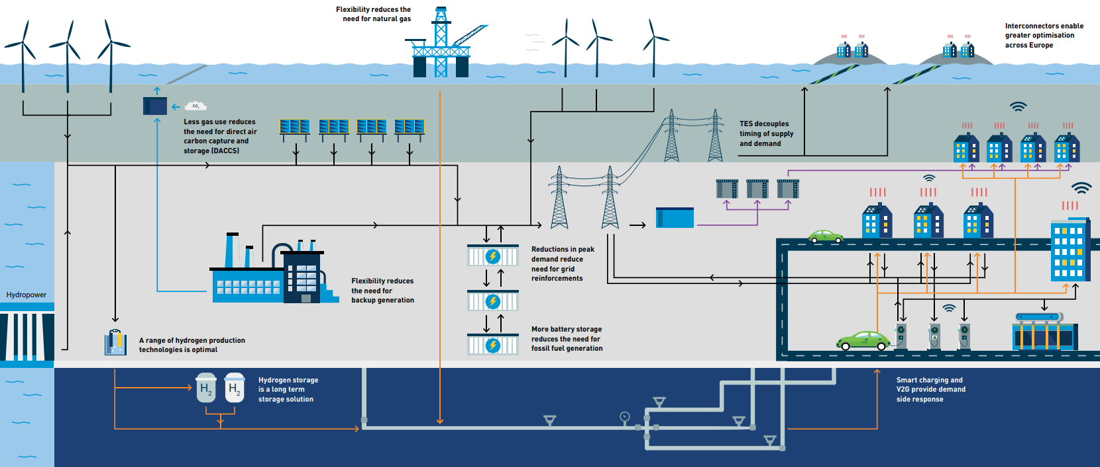
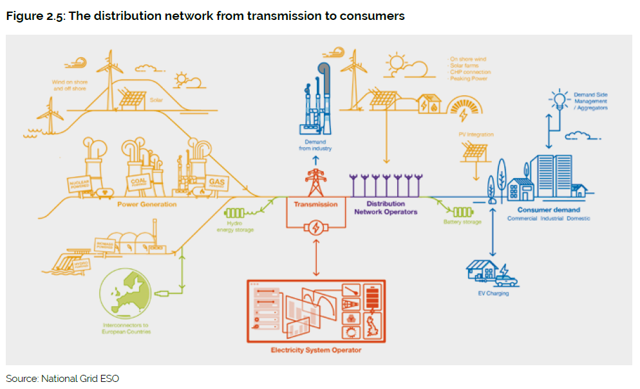
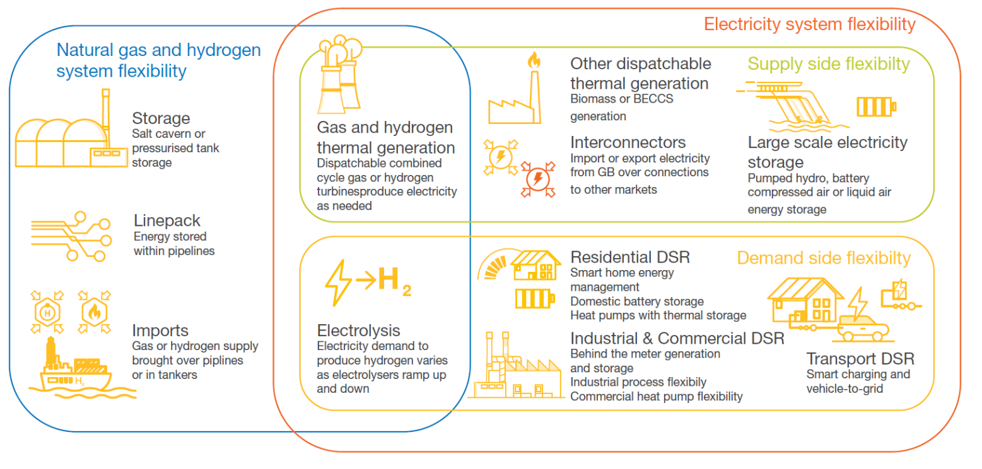

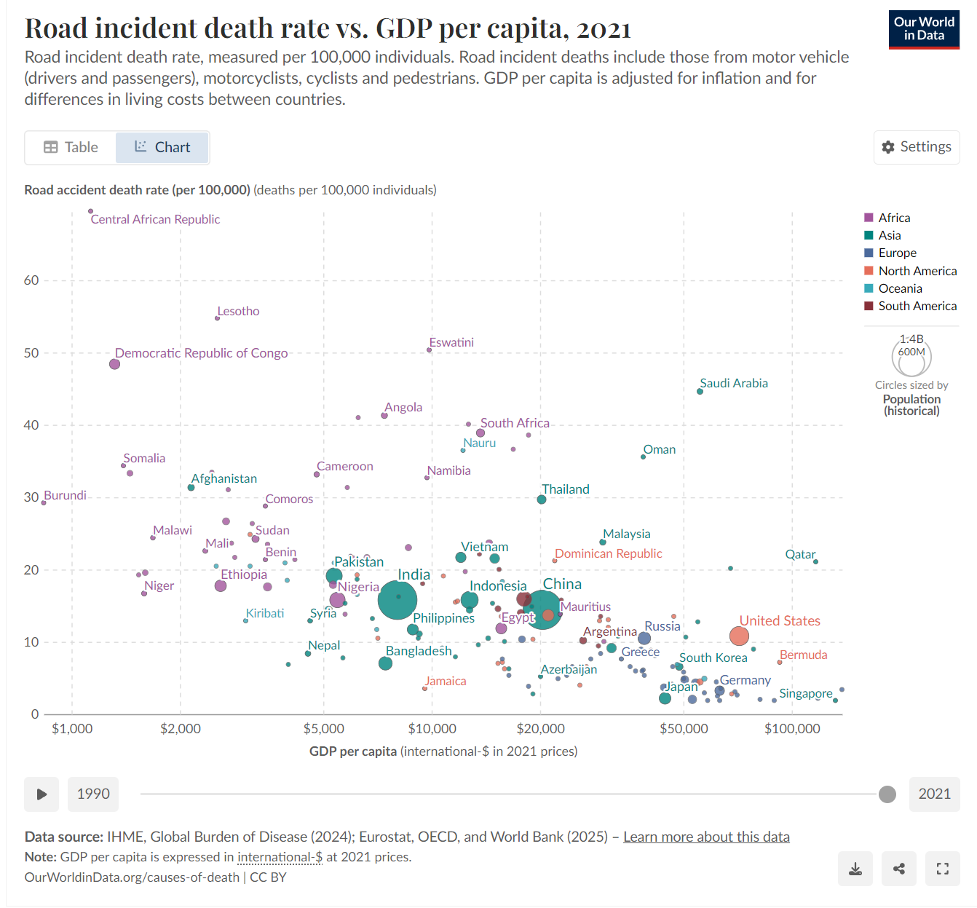
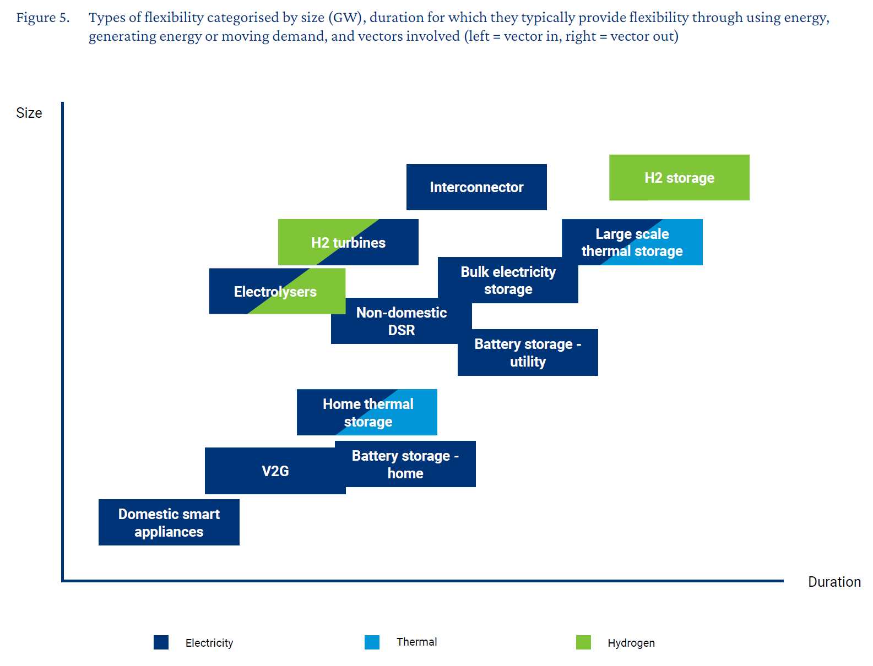
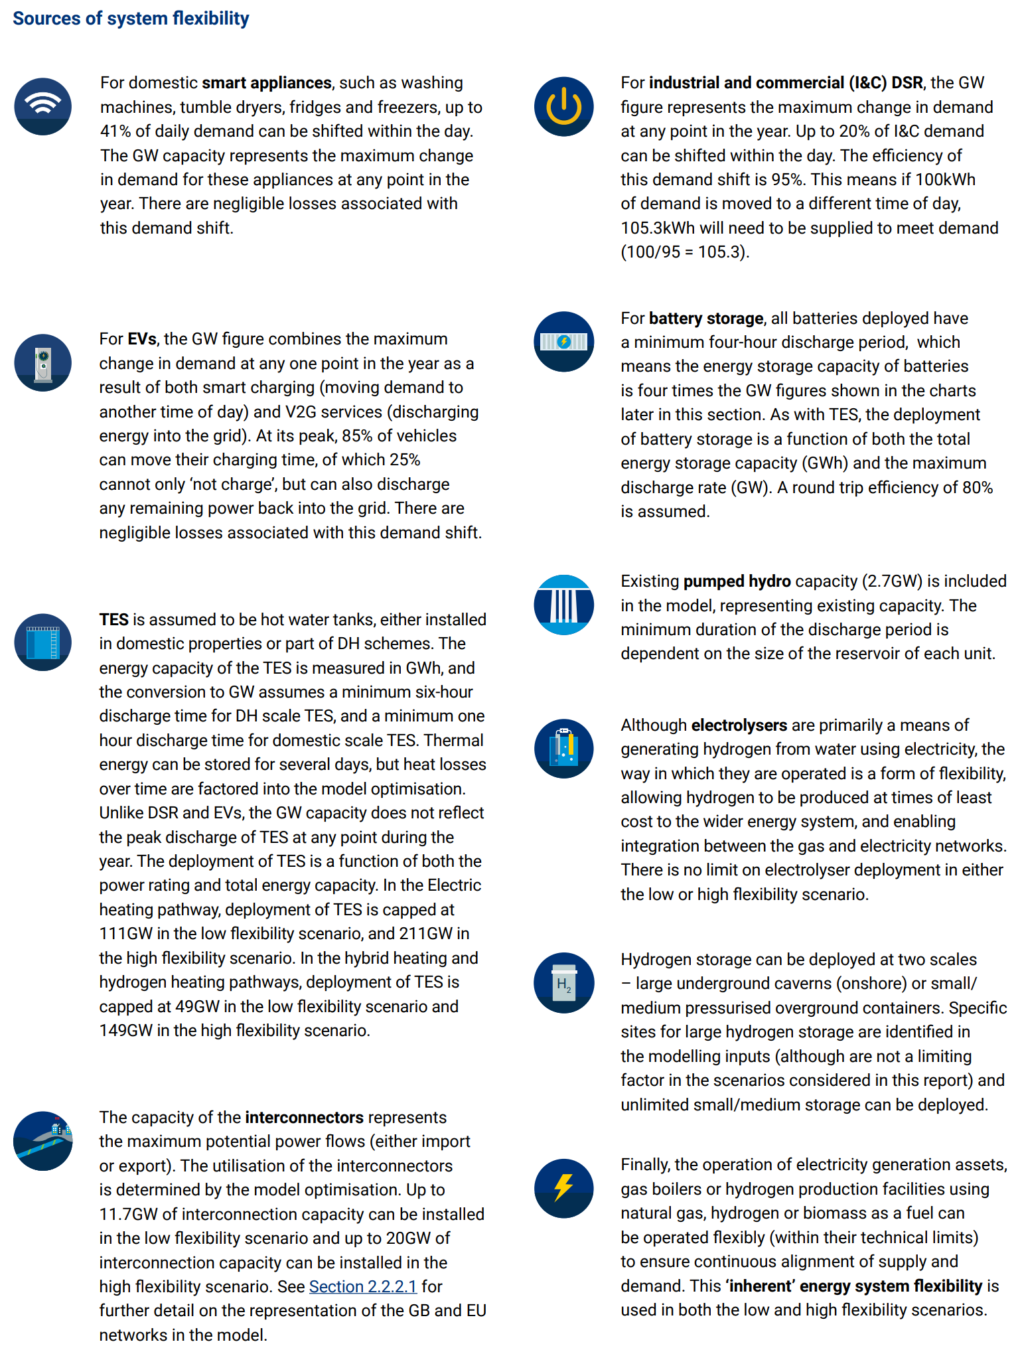
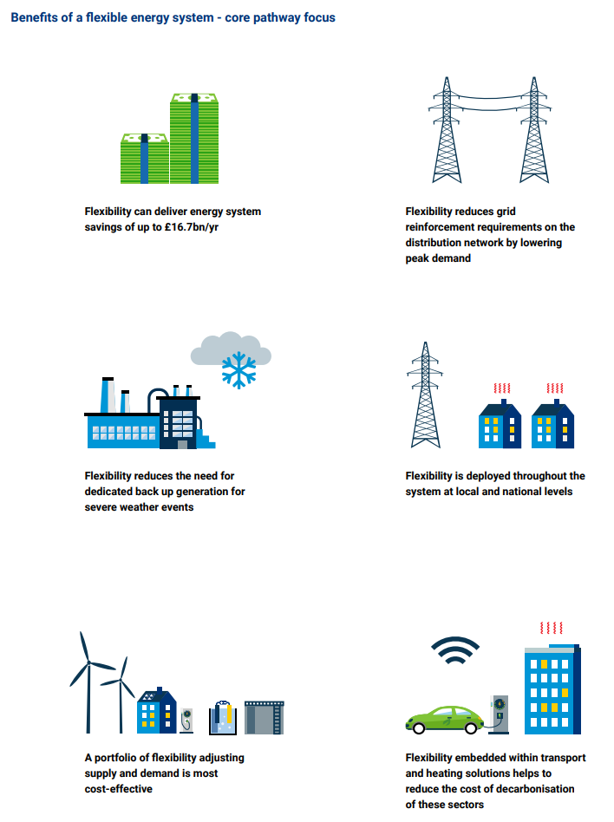
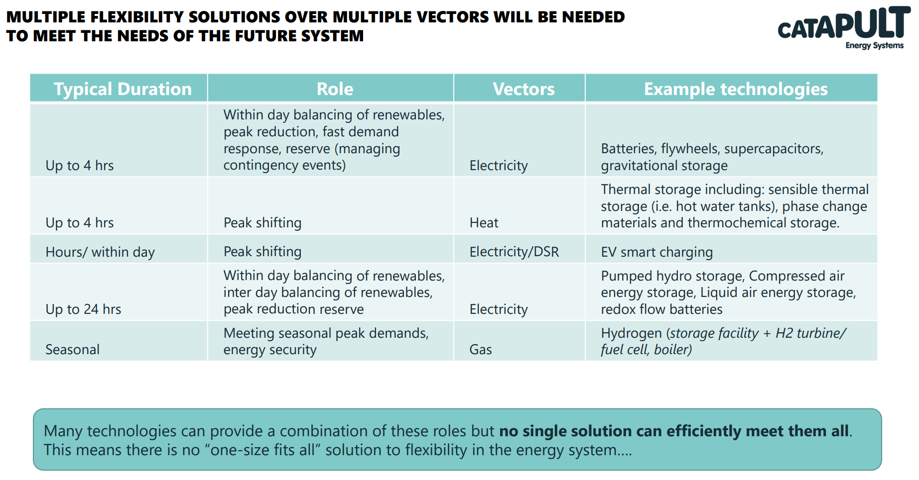
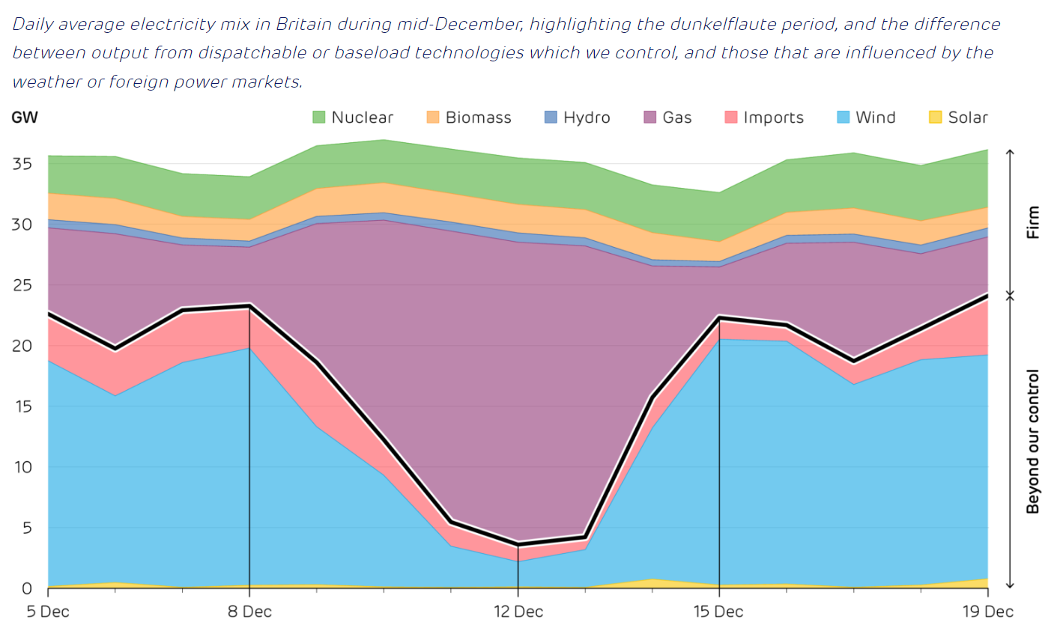
https://reports.electricinsights.co.uk/q4-2024/wind-droughts-show-the-need-for-low-carbon-flexible-generation/

